WEST KENT U3A SCIENCE STUDY DAY: TIME, SPACE & CONSERVATION

Programme
This Study Day brings together three speakers who have had distinguished careers as university lecturers and research scientists  Date Monday 22nd October 2018  Venue St Andrew’s Church,  Maidstone Rd. Paddock Wood, Kent,  TN12 6DZ  Time 9.15 am to 3.30 pm approx.  Cost £7.50 includes 3 lectures and  coffee  Lunch Please bring a packed lunch.  Refreshments will be available | 9.15 am  9.50 am  10.00 – 11.10 am  11.10 – 11.40 am  11.40 - 12.50 pm  12.50 - 2.10 pm  2.10 – 3.20 pm  3.30 pm | Registration and coffee on arrival  Welcome  Dr Chris Goodall: “It’s About Time”  Tea and coffee break  Professor David Southwood: “Cassini-Huygens: Odyssey to Saturn and Titan”  Lunch Break  Professor Alan Chadwick: “The Conservation of the Mary Rose”  Close
Organiser: Adrian Twiner: Tel. 01892 459352 Please retain for information
Chris Goodall is a retired Senior Lecturer in Astrophysics and Space Research at the University of Birmingham where he obtained his PhD in Electron Physics. He specialised in research in X-ray Astronomy and participated in the ESA Cornerstone mission using their largest X-ray telescope which was launched in 1999 and is still operational.  The three of nature’s clocks which define our calendar, namely the Earth’s rotation, the moon’s orbit and the Earth’s orbit round the Sun are not synchronised. This talk explores how man’s attempts to regularise the calendar have led to some interesting anomalies, of which Easter is perhaps the most significant. | David Southwood, a planetary scientist, is Chairman of the Steering Board of the UK Space Agency and Senior Research Investigator at Imperial College. He is a past President and a Fellow of the Royal Aeronautical Society and a Visiting Scientist at the NASA Jet Propulsion Laboratory. He built a space magnetometer at Imperial which operated in orbit around the planet Saturn aboard the NASA Cassini spacecraft from 2004 until 2017.  Some 30 years ago, Europe and the US agreed to explore the outer planets in a joint mission, Cassini-Huygens, to Saturn and its major moon, Titan. In 2017 the programme finally ended with the Cassini mothership deliberately diving into the Saturn atmosphere. The history of the programme will be outlined in this talk. | Alan Chadwick completed his PhD at Manchester University and served as a post-doctoral fellow at both the National Research Council of Canada in Ottawa and at the University of Strathclyde. He then moved to the University of Kent where his research has focused on solid state chemistry with a recent interest in nanomaterials. One of his current projects is in the development of conservation strategies for the Mary Rose.  This talk will give a brief history of the Mary Rose, the flagship of Henry VIII’s navy, followed by a detailed discussion of the conservation problems of the timbers and artefacts. Since 2004 the speaker has been using hard X-rays from synchrotrons to monitor and help to minimise the effects of the ‘sulphur problem’.

This Study Day is open to the members of any U3A in West Kent.
How to Apply: Fill in this part of the form indicating how many tickets at £7.50 per person you require.
Make your cheque payable to TW U3A and include a stamped self- addressed envelope (9” x 4”)
in order to receive your ticket(s), then send to:
West Kent U3A Study Day, A. Twiner, Flat 16, Bishops Court, Bishops Down Road, Tunbridge Wells, TN4 8XL

I/We wish to apply for 1 / 2 places for the West Kent U3A Science Study Day on Monday 22nd October 2018

Name(s) ……………………………………………………… Email ………………………………………

Address …………………………………………………….. Tel No ….................................................

………………………………………………………………… Home U3A ……………………………….
WEST KENT U3A SCIENCE STUDY DAY:

TIME, SPACE & CONSERVATION

on Monday 22nd October 2018
10.00 – 11.10 am
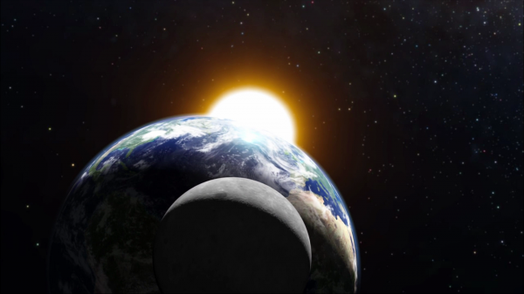
“It’s About Time”
Dr Chris Goodall will discuss
how man’s attempts to regularise the calendar have led to some interesting anomalies since the three of nature’s clocks which define our calendar, namely the Earth’s rotation, the moon’s orbit and the Earth’s orbit round the Sun, are not synchronised.

Public Domain Image from Desktop Wallpaper HD.
11.40 am – 12.50 pm
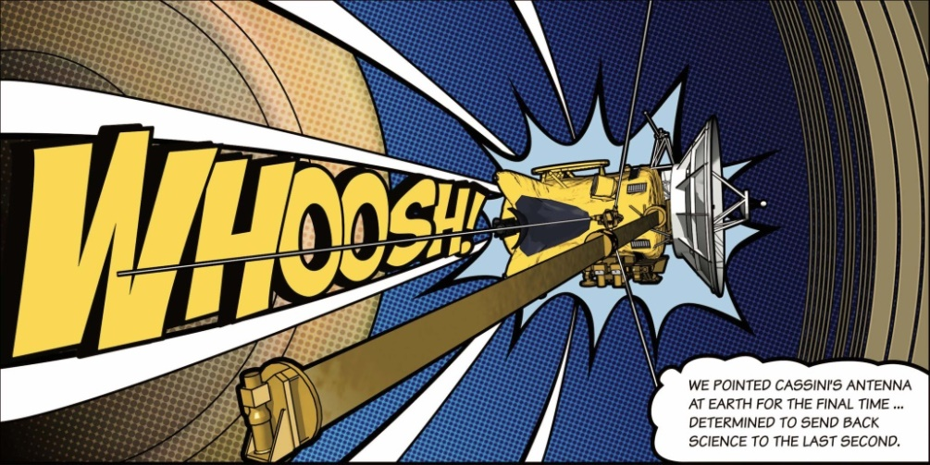
“Cassini-Huygens: Odyssey to Saturn and Titan”

Professor David Southwood
will relate the history of the joint Europe/US Cassini-Huygens mission to explore Saturn and its major moon, Titan. In 2017 the programme finally ended with the Cassini mothership deliberately diving into the Saturn atmosphere.
2.10 – 3.20 pm Image Courtesy NASA/JPL-Caltech
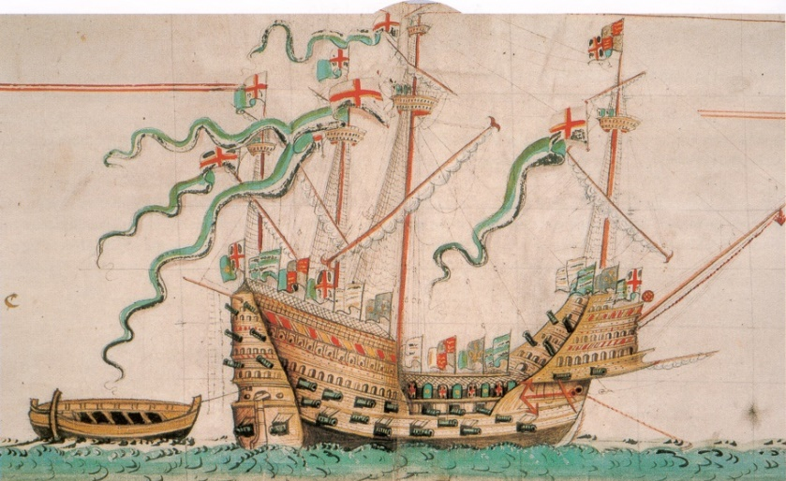
“The Conservation of the Mary Rose”
Professor Alan Chadwick will give a brief history of the Mary Rose, the flagship of Henry VIII’s navy, followed by a detailed discussion of the conservation problems of the timbers and artefacts, with particular reference to nanotechnology.

FULL DETAILS OF THE STUDY DAY
AND THE APPLICATION FORM ARE
The Mary Rose from the Anthony Roll of Henry VIII's Navy (1546) IN THE NEWSLETTER.
By Own scan. Photo by Gerry Bye. Original by Anthony Anthony.
[Public domain], via Wikimedia Commons

