WEST KENT U3A SCIENCE STUDY DAY:

TIME, SPACE & CONSERVATION

on Monday 22nd October 2018
10.00 – 11.10 am
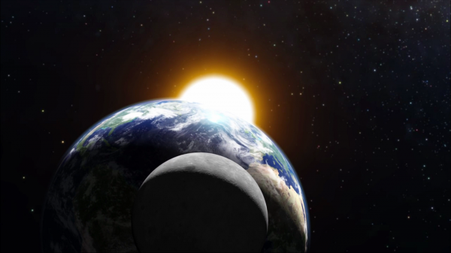
“It’s About Time”
Dr Chris Goodall will discuss
how man’s attempts to regularise the calendar have led to some interesting anomalies since the three of nature’s clocks which define our calendar, namely the Earth’s rotation, the moon’s orbit and the Earth’s orbit round the Sun, are not synchronised.

Public Domain Image from Desktop Wallpaper HD.
11.40 am – 12.50 pm
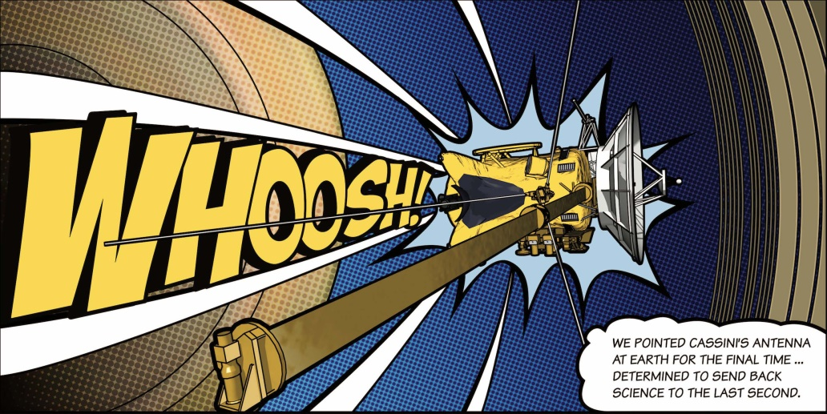
“Cassini-Huygens: Odyssey to Saturn and Titan”

Professor David Southwood
will relate the history of the joint Europe/US Cassini-Huygens mission to explore Saturn and its major moon, Titan. In 2017 the programme finally ended with the Cassini mothership deliberately diving into the Saturn atmosphere.

2.10 – 3.20 pm Image Courtesy NASA/JPL-Caltech
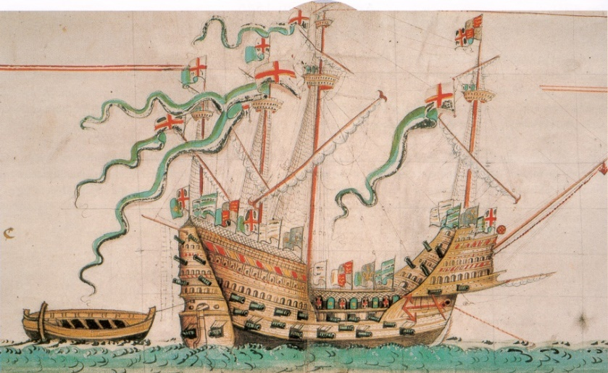
“The Conservation of the Mary Rose”
Professor Alan Chadwick will give a brief history of the Mary Rose, the flagship of Henry VIII’s navy, followed by a detailed discussion of the conservation problems of the timbers and artefacts, with particular reference to nanotechnology.

FULL DETAILS OF THE STUDY DAY
AND THE APPLICATION FORM ARE
The Mary Rose from the Anthony Roll of Henry VIII's Navy (1546) IN THE NEWSLETTER.
By Own scan. Photo by Gerry Bye. Original by Anthony Anthony.
[Public domain], via Wikimedia Commons

